Timestamp

Definition:
# Source: AI Source: Provided by: [Data Path: Persons Table -> ID Column: 1, Name_En Column: Motasem Essam] -> From: [ChatGPT] on [1/26/2026]
A timestamp is a piece of data that records the exact date and time when something happened.
It’s used in many places, for example:
- Computers & programming: to mark when a file was created, modified, or when an event occurred.
- Messages & emails: to show when a message was sent or received.
- Databases hookup: to track when records are added or updated.
- Security & logging: to record events in systems (logins, errors, transactions).

Example
# Source: AI Source: Provided by: [Data Path: Persons Table -> ID Column: 1, Name_En Column: Motasem Essam] -> From: [ChatGPT] on [1/26/2026]
- 2026-02-10 14:35:22 → Year-Month-Day Hour:Minute:Second
- Unix timestamp: 1765444522 → number of seconds since Jan 1, 1970 (UTC)

How timestamps work in programming

What a timestamp is in programming
# Source: AI Source: Provided by: [Data Path: Persons Table -> ID Column: 1, Name_En Column: Motasem Essam] -> From: [ChatGPT] on [1/26/2026]
A timestamp is a numeric representation of time, usually the number of seconds (or milliseconds) since the Unix Epoch:
- Unix Epoch: 1970-01-01 00:00:00 UTC
- Examples:
  - Seconds: 1765444522 → Feb 10, 2026
  - Milliseconds: 1765444522000 → same time in milliseconds
Programs use timestamps because they are:
- Easy to store and compare
- Independent of time zones
- Ideal for calculations (like time differences)

Timestamps in Python
# Source: AI Source: Provided by: [Data Path: Persons Table -> ID Column: 1, Name_En Column: Motasem Essam] -> From: [ChatGPT] on [1/26/2026]
Get current timestamp (seconds)
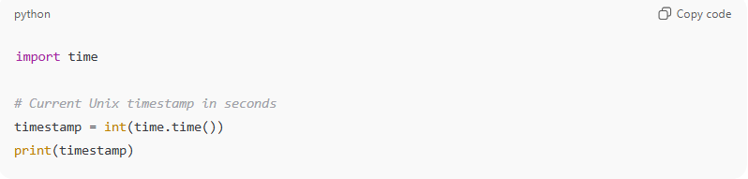
import time

# Current Unix timestamp in seconds
timestamp = int(time.time())
print(timestamp)
Convert timestamp to human-readable date
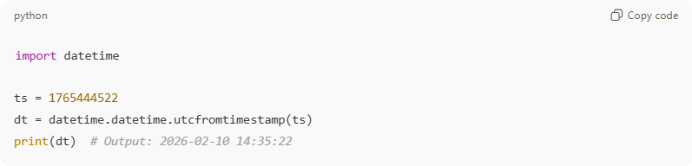
import datetime

ts = 1765444522
dt = datetime.datetime.utcfromtimestamp(ts)
print(dt) # Output: 2026-02-10 14:35:22
Convert human date to timestamp
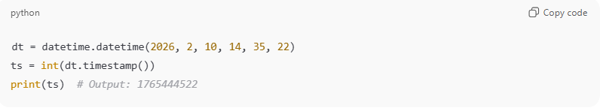
dt = datetime.datetime(2026, 2, 10, 14, 35, 22)
ts = int(dt.timestamp())
print(ts) # Output: 1765444522

Timestamps in JavaScript
# Source: AI Source: Provided by: [Data Path: Persons Table -> ID Column: 1, Name_En Column: Motasem Essam] -> From: [ChatGPT] on [1/26/2026]
Current timestamp (milliseconds)
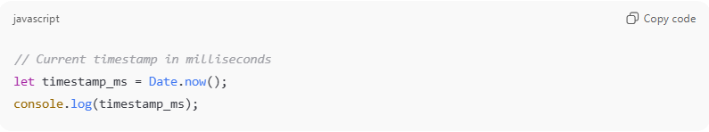
// Current timestamp in milliseconds
let timestamp_ms = Date.now();
console.log(timestamp_ms);
Current timestamp in seconds
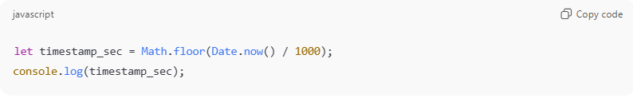
let timestamp_sec = Math.floor(Date.now() / 1000);
console.log(timestamp_sec);
Convert timestamp to human-readable date
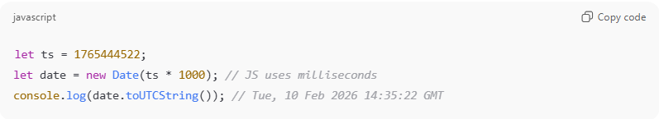
let ts = 1765444522;
let date = new Date(ts * 1000); // JS uses milliseconds
console.log(date.toUTCString()); // Tue, 10 Feb 2026 14:35:22 GMT
Convert date to timestamp
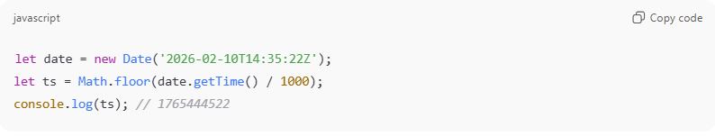
let date = new Date('2026-02-10T14:35:22Z');
let ts = Math.floor(date.getTime() / 1000);
console.log(ts); // 1765444522

Common operations with timestamps
# Source: AI Source: Provided by: [Data Path: Persons Table -> ID Column: 1, Name_En Column: Motasem Essam] -> From: [ChatGPT] on [1/26/2026]
- Calculate time differences: timestamp2 - timestamp1 → seconds between two events
- Sort events by time: compare timestamps
- Schedule future actions: add seconds to a timestamp and check if it’s reached
- Time zones: timestamps are UTC, local time is applied when displaying

Summary
# Source: AI Source: Provided by: [Data Path: Persons Table -> ID Column: 1, Name_En Column: Motasem Essam] -> From: [ChatGPT] on [1/26/2026]
- Programming timestamps are usually seconds or milliseconds since Jan 1, 1970 UTC
- Python uses time and datetime modules
- JavaScript uses Date objects and Date.now()
- They are ideal for calculations, comparisons, and storing time in databases

